

**KE5108: Tutorial 2**

1. Fig. 1 (a) shows an image composed of white circles with black inner spots. This is an image which is the result from thresholding into two levels a scene containing polished ball earings. The dark spots inside the circles are the results of reflections. Device an image processing procedure to eliminate the reflections for the two following cases, i.e. to detect and turn the dark spots within the spheres to bright.
2. The circles are not touching each other as shown in Fig. 1(a).
3. Some of the circles are touching each other thus forming dark regions between them

as shown in Fig. 1(b).

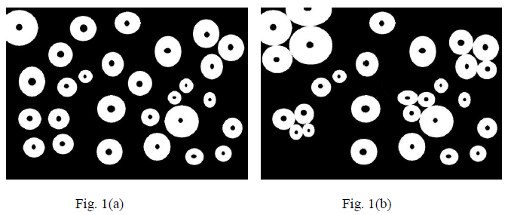

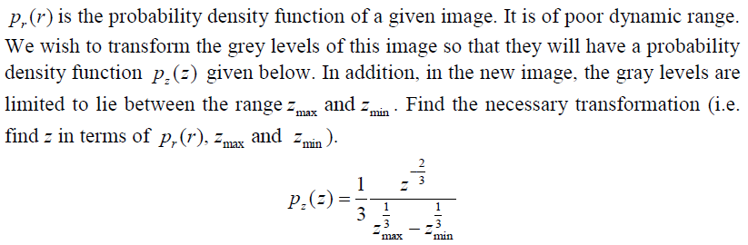

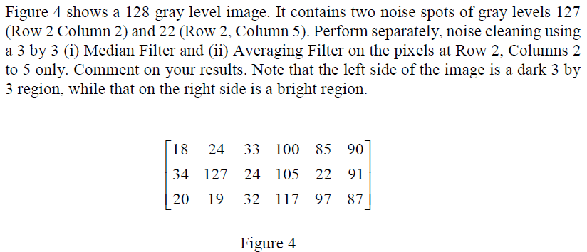

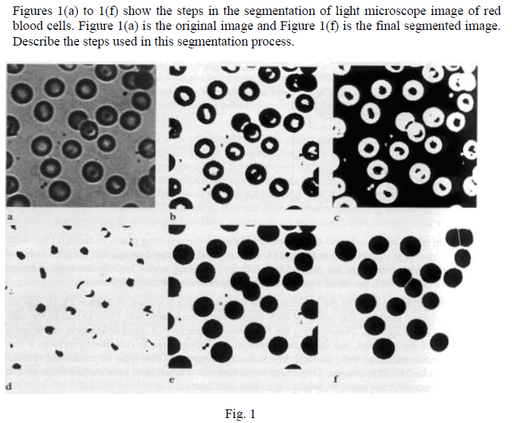

1. In the aviation industry, luggage are loaded onto planes in crates as shown in the figure below. These crates are labelled with distinct numbers on the sides for tracking. Some issues faced during imaging includes partially faded numbers and black dirt on the labels. Present an approach, based on what you have learnt during the lecture, to tackle this issue to increase the accuracy in identification of the numbers.

